Artificial Neural Networks
Data Set: Churn_Modelling (Bank Customers)

Import Libraries

import numpy as np
import pandas as pd
import tensorflow as tf
import os

Check TensorFlow/ Python Version

print ('Python Version')
!python --version
print ('Tensor Flow Version',tf.__version__)

Load Data Set

os.chdir('C:\\Noble\\Training\\Course Content\\Deep Learning\\Training\\Data\\')
dataset = pd.read_csv('Churn_Modelling.csv')
display (dataset)

Create X

X = dataset.iloc[:, 3:-1].values
print (X)

Create Y

y = dataset.iloc[:, -1].values
print (y)

Label Encoding – Gender

from sklearn.preprocessing import LabelEncoder
le = LabelEncoder()
X[:, 2] = le.fit_transform(X[:, 2])
print (X)

One Hot Encoding – Geography

from sklearn.compose import ColumnTransformer
from sklearn.preprocessing import OneHotEncoder
ct = ColumnTransformer(transformers=[('encoder', OneHotEncoder(), [1])], remainder='passthrough')
X = np.array(ct.fit_transform(X))
print (X)

Print X Shape

print (X.shape)

Train Test Split

from sklearn.model_selection import train_test_split
X_train, X_test, y_train, y_test = train_test_split(X, y, test_size = 0.2, random_state = 0)
print (X.shape)
print (X_train.shape)
print (X_test.shape)

Standardization Training Data

from sklearn.preprocessing import StandardScaler
sc = StandardScaler()
X_train = sc.fit_transform(X_train)
display (pd.DataFrame(X_train ))

Standardization Test Data

X_test = sc.transform(X_test)
display (pd.DataFrame(X_test ))

Building the ANN
Initialize Artificial Neural Network as a sequence of Layers
The Sequential class in Keras is a simple and straightforward way to build neural networks.
It allows you to create a model by stacking layers on top of each other in a linear fashion.

ann = tf.keras.models.Sequential()

Create an input Layer
add() method: Appends a layer instance to the model.
tf.keras.layers.Dense is a fully connected layer in TensorFlow's Keras API, where each neuron receives input from every neuron in the previous layer
Units = Number of Neurons in input layer
Activation function = ‘relu’- rectifier

ann.add(tf.keras.layers.Dense(units=6, activation='relu'))

Create the First Hidden Layer
ann.add(tf.keras.layers.Dense(units=6, activation='relu'))

Create the Second Hidden Layer
ann.add(tf.keras.layers.Dense(units=6, activation='relu'))

Create output layer

ann.add(tf.keras.layers.Dense(units=1, activation='sigmoid'))
Training ANN
Compiling the ANN

Optimizers
Optimization algorithms helps us to minimize (or maximize) an Objective function (another name for Error function) E(x) which is simply a mathematical function dependent on the Model’s internal learnable parameters which are used in computing the target values(Y) from the set of predictors(X) used in the model.

Binary cross-entropy
Binary cross-entropy is a loss function used in machine learning for binary classification problems, measuring the difference between predicted probabilities and true binary labels.

During training, the model's weights are adjusted to reduce the loss, which encourages the model to produce probabilities closer to the true labels.

ann.compile(optimizer = 'adam', loss = 'binary_crossentropy', metrics = ['accuracy'])

Training the Model
Default Batch Size = 32 , epochs = Random Number

ann.fit(X_train, y_train, batch_size = 32, epochs = 100)

Print Model Summary
print (ann.summary())
Prediction (prediction will be at percentage)
y_pred = ann.predict(X_test)
print (y_pred)

Convert the prediction percentage to actual result
Assume 0.5 is the threshold for sigmoid activation

y_pred = (y_pred > 0.5)
print(np.concatenate((y_pred.reshape(len(y_pred),1), y_test.reshape(len(y_test),1)),1))

Save the result in excel

Execute the statement at Anaconda prompt
!pip install openpyxl

from openpyxl import Workbook
result = np.concatenate((X_test, y_test.reshape(len(y_test),1),y_pred.reshape(len(y_pred),1)),1)
result = pd.DataFrame(result )
display (result)
from openpyxl import Workbook
result.to_excel ("C:\\Noble\\Training\\DS Temporary Files\\ann_Churn_Modelling.xlsx")

Create accuracy score , classification report and Confusion Matrix for test data
from sklearn.metrics import confusion_matrix, accuracy_score,classification_report
print ("Accuracy")
print (accuracy_score(y_test, y_pred))
print ()
print ('Classification Report')
print (classification_report (y_test, y_pred,zero_division = 0))
print ()
cm = confusion_matrix(y_test, y_pred)
print(cm)

Prediction for complete data
X_STD = sc.transform(X)
y_full_pred = ann.predict(X_STD )
y_full_pred = (y_full_pred > 0.5)
from sklearn.metrics import confusion_matrix, accuracy_score,classification_report
print ("Accuracy")
print (accuracy_score(y, y_full_pred))
print ()
print ('Classification Report')
print (classification_report (y, y_full_pred,zero_division = 0))
print ()
cm = confusion_matrix(y,y_full_pred)
print(cm)
Predict for Future Values
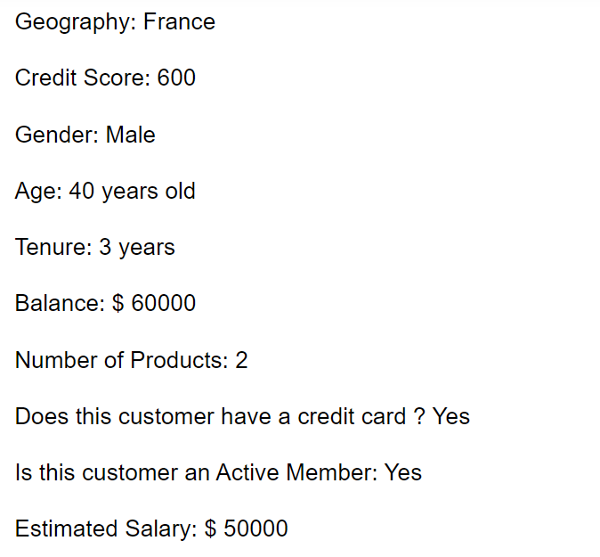

print(ann.predict(sc.transform([[1, 0, 0, 600, 1, 40, 3, 60000, 2, 1, 1, 50000]])) > 0.5)

Machine Learning Decision Tree model to compare with ANN

Import Libraries

import numpy as np
import pandas as pd
import os

Update Working Directory
os.chdir('C:\\Noble\\Training\\Course Content\\Deep Learning\\Training\\Data\\')
os.getcwd()

Load the Data Set

dataset = pd.read_csv('Churn_Modelling.csv')
display (dataset)

Create X

X = dataset.iloc[:, 3:-1].values
print (X)

Create Y

y = dataset.iloc[:, -1].values
print (y)

Label Encoding – Gender

from sklearn.preprocessing import LabelEncoder
le = LabelEncoder()
X[:, 2] = le.fit_transform(X[:, 2])
print (X)

One Hot Encoding – Geography

from sklearn.compose import ColumnTransformer
from sklearn.preprocessing import OneHotEncoder
ct = ColumnTransformer(transformers=[('encoder', OneHotEncoder(), [1])], remainder='passthrough')
X = np.array(ct.fit_transform(X))
print (X)

Print X Shape
print (X.shape)

Standardization of the Data Set

from sklearn.preprocessing import StandardScaler
sc = StandardScaler()
X_STD = sc.fit_transform(X)
display (pd.DataFrame(X_STD ))

Train Test Split

from sklearn.model_selection import train_test_split
X_train, X_test, y_train, y_test = train_test_split(X_STD, y, test_size = 0.2, random_state = 0)
print (X_STD.shape)
print (X_train.shape)
print (X_test.shape)
Create a Decision Tree model

from sklearn.tree import DecisionTreeClassifier
dtc = DecisionTreeClassifier()
dtc.fit (X_train,y_train)
print (dtc)

Prediction with Test Data

y_pred = dtc.predict(X_test)
from sklearn.metrics import confusion_matrix, accuracy_score,classification_report
print ("Accuracy")
print (accuracy_score(y_test, y_pred))
print ()
print ('Classification Report')
print (classification_report (y_test, y_pred))
print ()
cm = confusion_matrix(y_test, y_pred)
print(cm)

Prediction with Complete Data

yfull_pred = dtc.predict(X_STD)
from sklearn.metrics import confusion_matrix, accuracy_score,classification_report
print ("Accuracy")
print (accuracy_score(y,yfull_pred))
print ()
print ('Classification Report')
print (classification_report (y,yfull_pred))
print ()
cm = confusion_matrix(y,yfull_pred)
print(cm)

